

**“Project Plan and Fourth Increment”**

**“Spring 2017”**

# “Submitted by **Team 13”**

Onica Sai Prasanna Lakshmi, Rayineedi– 80

Venkata Krishna, Podili– 72

Mamatha Yadav, Chekuti– 11

Sreelekha Reddy, Kommareddy– 45

**Table of Contents**

1. Introduction 3
2. Project Deployment & Project Management

2.1 Landing Page 4

2.2 Login Page 5

2.3 Registration Page 6

2.4 Facebook Login 7

2.5 Home Page of Application 8

2.6 Retrieving Food Results from Four Square API 9

2.7 Retrieving Event Results from Four Square API 10

2.8 Retrieving Places Results from Four Square API 11

2.9 Retrieving Travel & Transport Results from Four Square API 12

2.10 Location from Google Maps API 13

2.11 Scheduling a visit 14

2.12 Notification Bar 15

2.13 Searching depending on Location and Attribute opted by user 16

2.14 Storing data in M-Lab 23

2.15 Management 24

2.16 Final Project Evaluation 25

1. Project Proposal 26
2. Project Plan

4.1 Class Diagram 27

4.2 Sequence Diagram 28

4.3 Software Architecture 30

4.4 Use Case Diagram 32

4.5 User Stories 33

4.6 Unit Testing 34

1. Project First Increment 35
2. Project Second Increment 35
3. Project Third Increment 36
4. Project Fourth Increment 37
5. Project Management 38
6. Future Scope 40
7. Bibliography 40

**1. Introduction**

**“City Guide”** When we keep travelling to different places, there is always a limitation of information about the place and information we are travelling to. Therefore, this encouraged us for a travel guide mobile application as smartphones are evolving exponentially and becoming popular to offer greater services to multiple users using their Geo-Location etc. We as tourists will be able to know and explore many new tourists’ places just by viewing the information in the application. This will also enable easy travel planning by knowing the Places, Events and developments happening all around the places we visited.

**2. Project Deployment & Project Management**

**Application:**

**Guidelines for a User:**

2.1 Landing Page of the Application:

By launching the application, A landing page is displayed which consists of Login, Register buttons along with the Facebook login button.

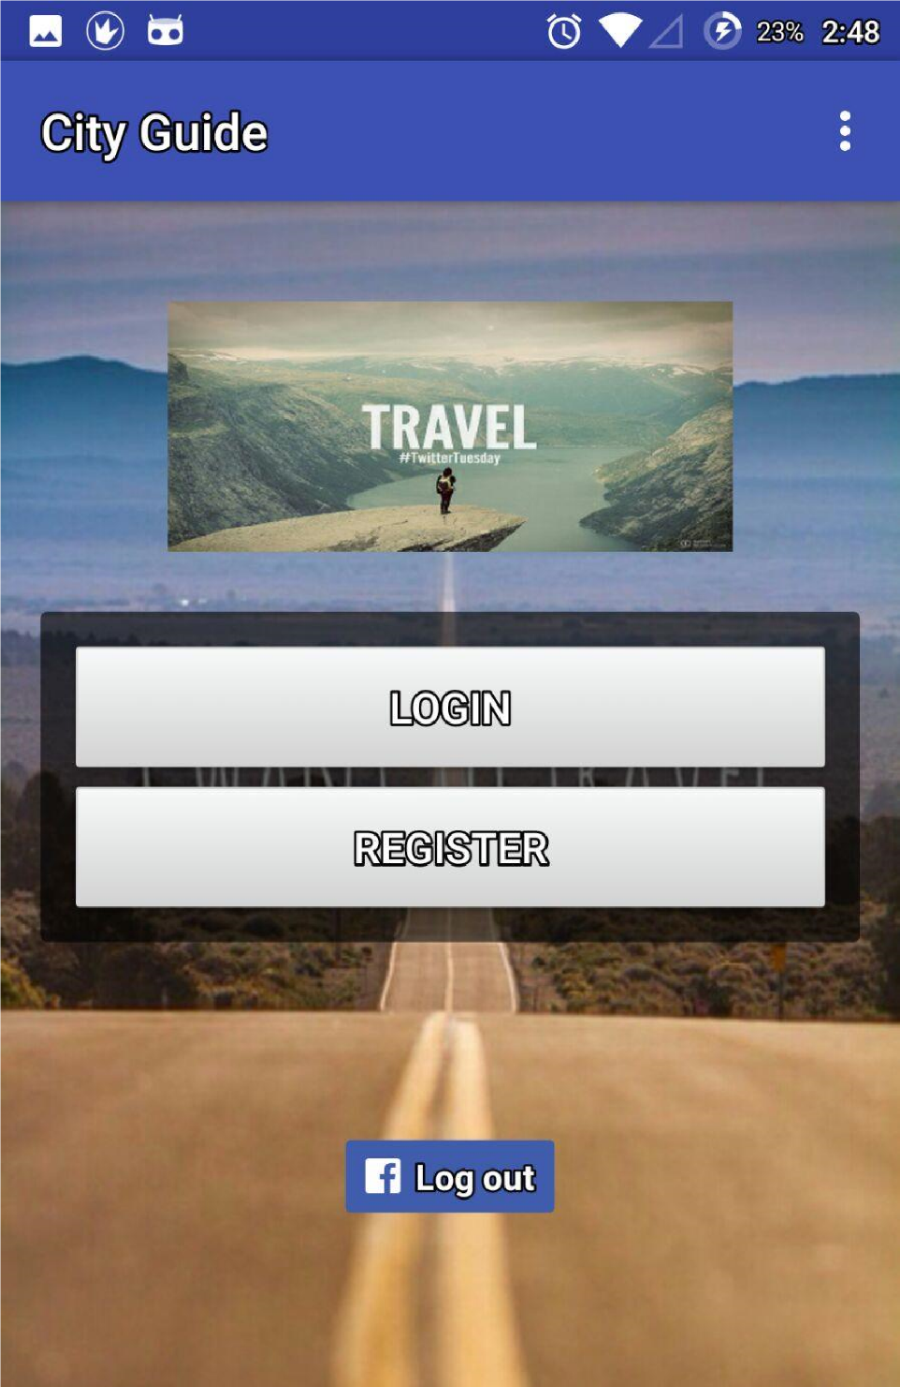

2.2 Login Page:

By clicking on the Login Button the Application gets navigated to the Login Page which consists of Email and Password attributes, after filling the details user clicks on login after successful login user gets navigated to the Home Page. If the user is new to the application then by clicking on “No account yet? Create one” the user gets navigated to registration page where he can register to use the application.

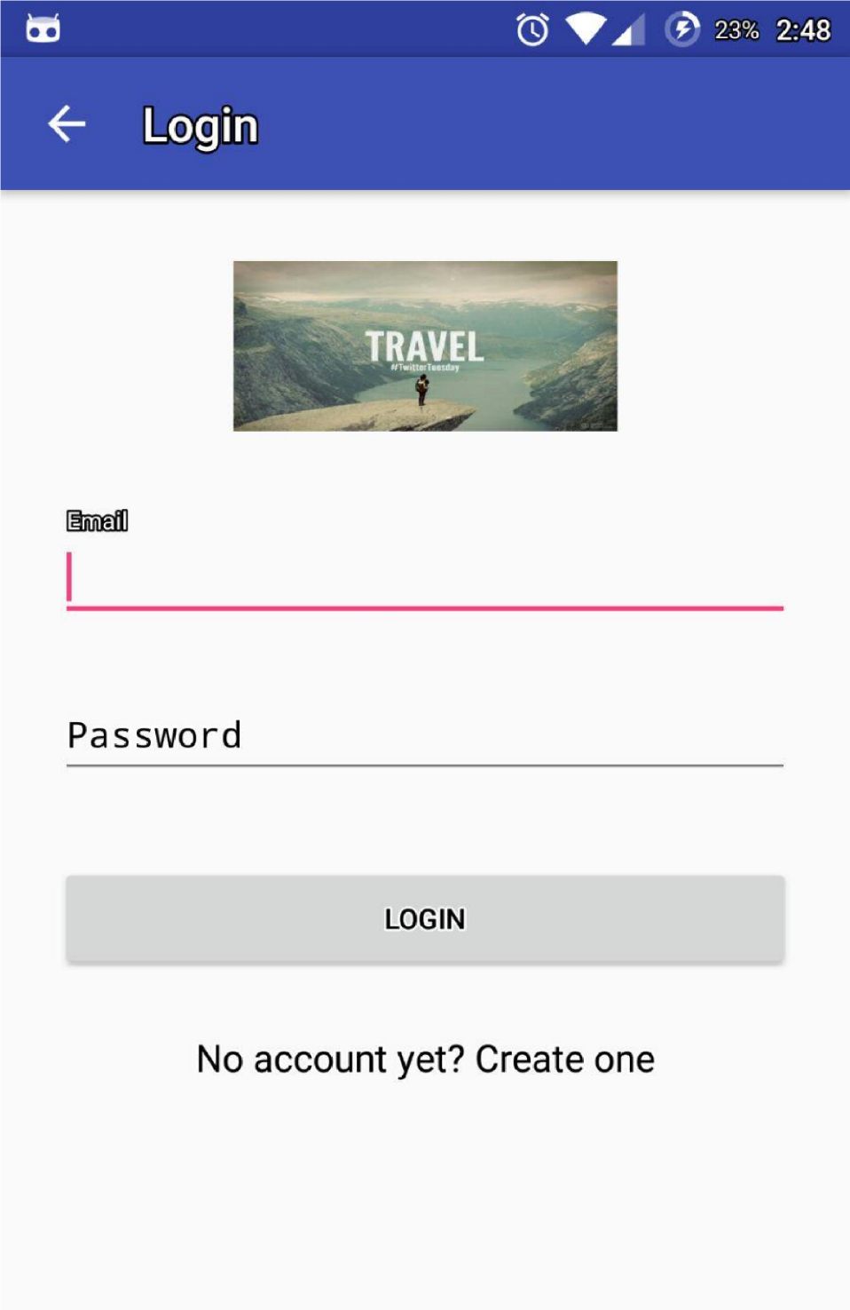

2.3 Registration Page:

If the user is new to application, by clicking on the Register button in the landing page he gets navigated to the registration page where Name, Email, Password, and Mobile Number attributes are present. After Clicking on the register button user gets registered and navigated to login page and after successful login he gets navigated to home page.

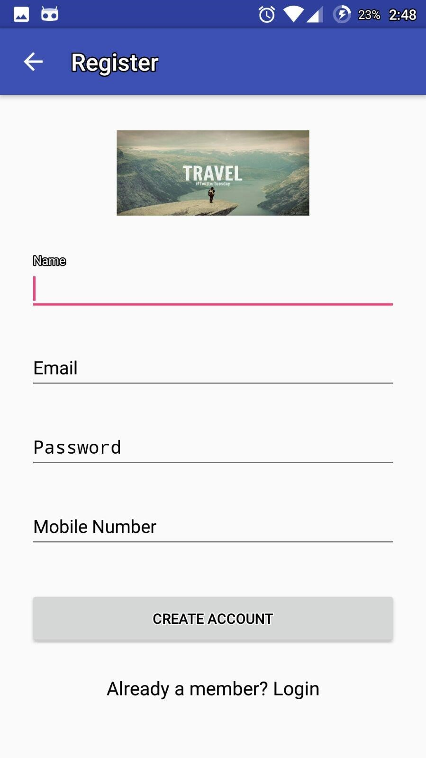

2.4 Facebook Login:

User can also use his Facebook credentials to use the application, by clicking on the Facebook login button in landing page.

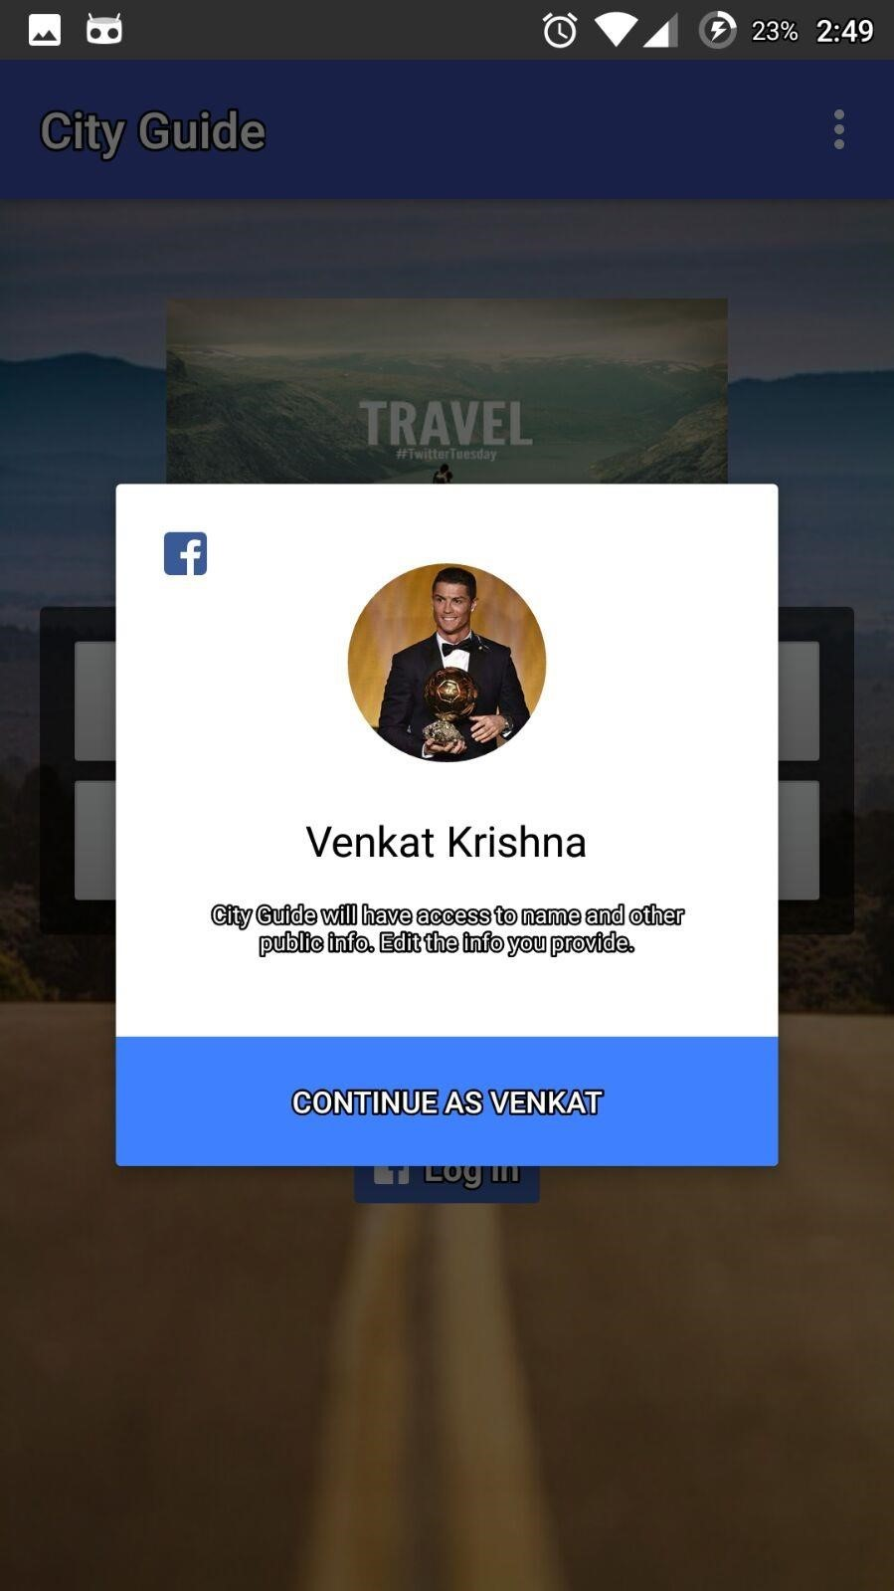

2.5 Home Page of the Application:

Home page which describes the features of the application will be displayed after successful login of the user. This page consists of Food, Events, Places, Travel and Transport and My Schedule by clicking on these icons respective results will get displayed.

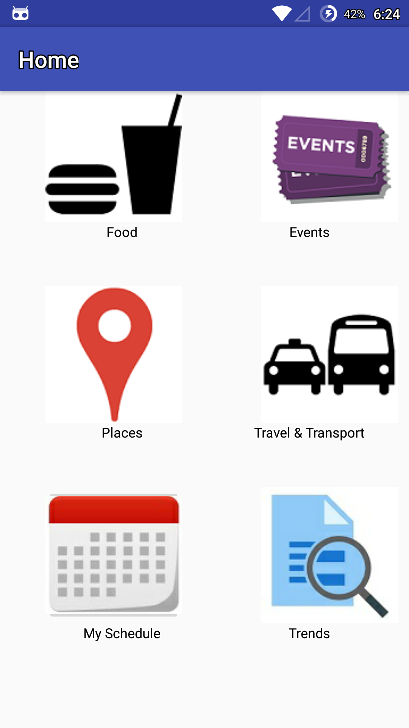

2.6 Retrieving Food Results from Four Square API:

By Clicking on Food Icon on the Home page, the following are the results, will be displayed according to the Geo-Location of the User.

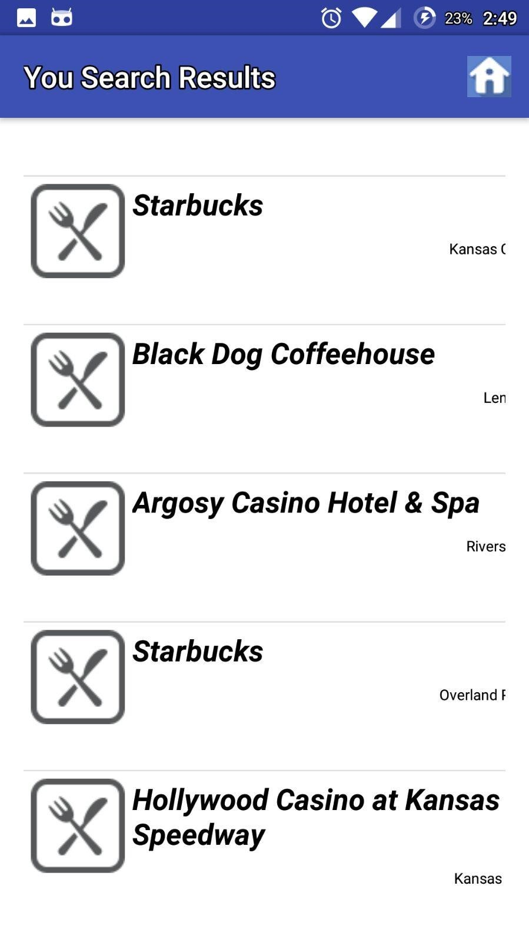

2.7 Retrieving Events Results from Four Square API:

By Clicking on Events Icon on the Home page, the following are the results, will be displayed according to the Geo-Location of the User.

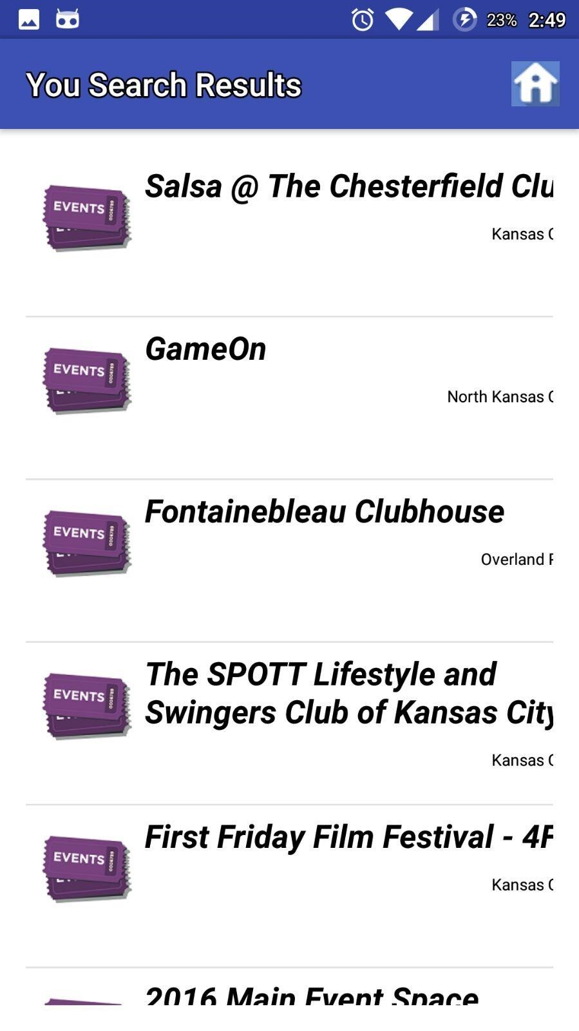

2.8 Retrieving Places Results from Four Square API:

By Clicking on Places Icon on the Home page, the following are the results, will be displayed according to the Geo-Location of the User.

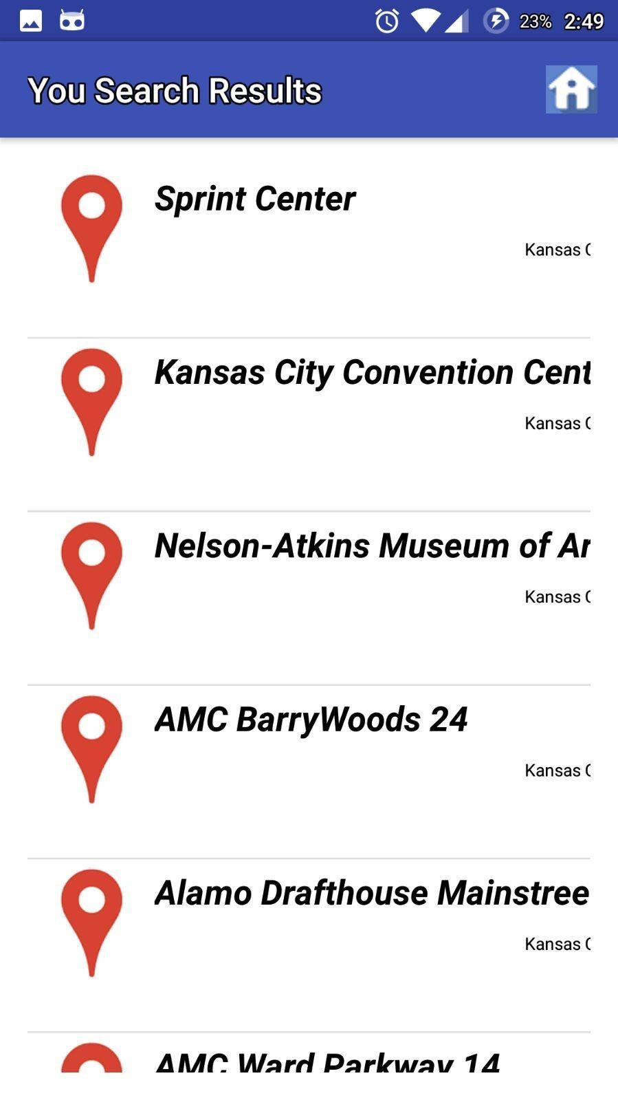

2.9 Retrieving Travel & Transport Results from Four Square API:

By Clicking on Travel & Transport Icon on the Home page, the following are the results, will be displayed according to the Geo-Location of the User.

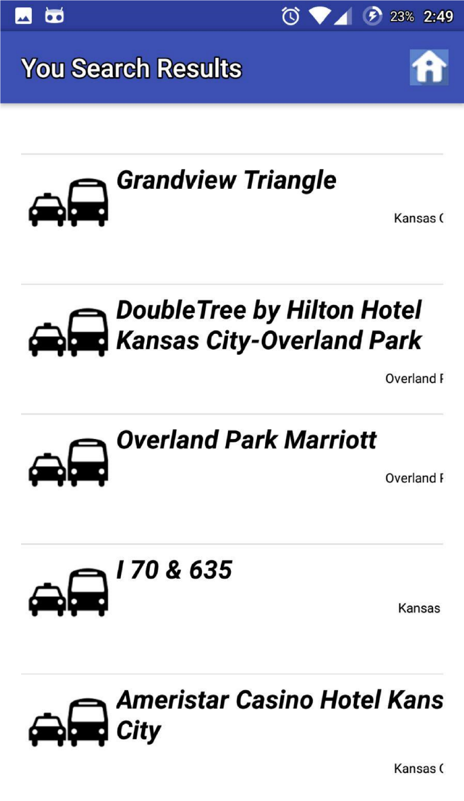

2.10 Retrieving Location from G-Maps API:

By clicking on an event, place, or restaurant it’s address, and location on map along with the option of scheduling the event as task is displayed.

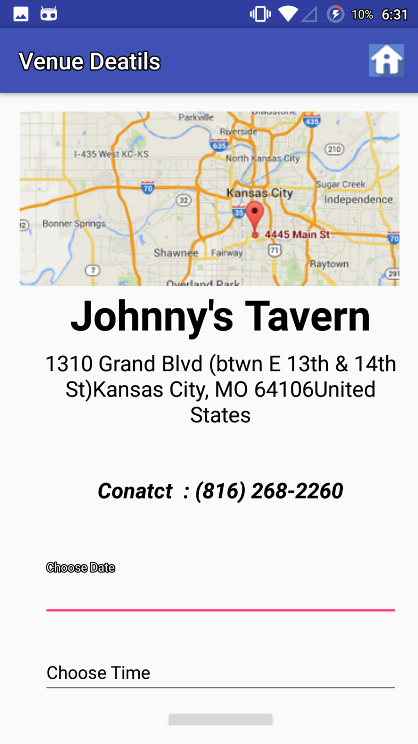

2.11 Scheduling a Visit:

* Choose date and time attributes, present on the results page, where the user can choose date and time to schedule his event.
* These events can be viewed later, by clicking on my schedule icon, where a button for notification is placed and by clicking on that the user can get the notifications for the added events.

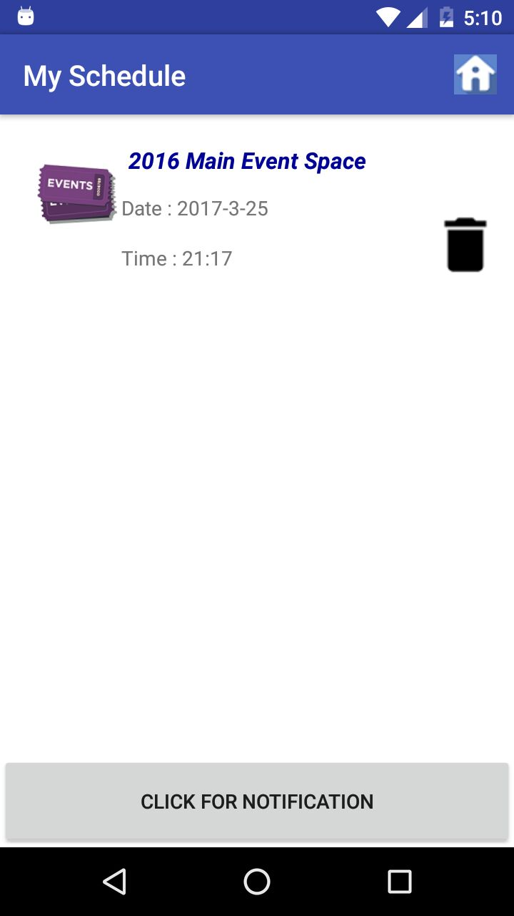

2.12 Notification Bar:

By Clicking on “Click for Notifications” The user will get Notifications based on the time he used.

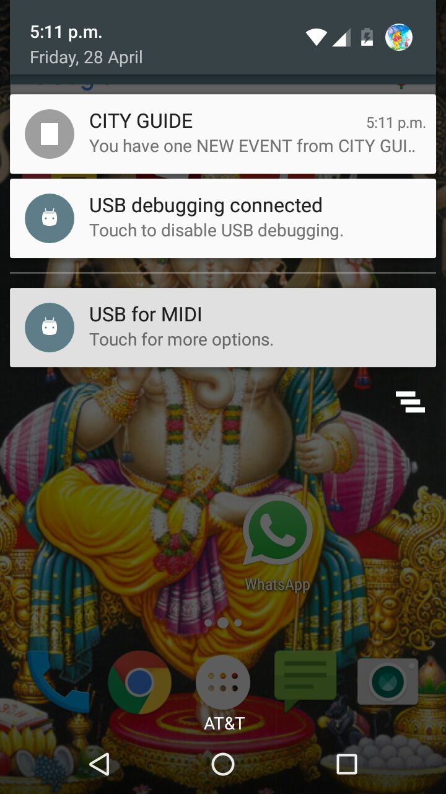

2.13 Searching Depending on Location Opted by the User:

If the User wants to search in other places other than geolocation he can do through the following page, which will get displayed by clicking on Trends Icon.

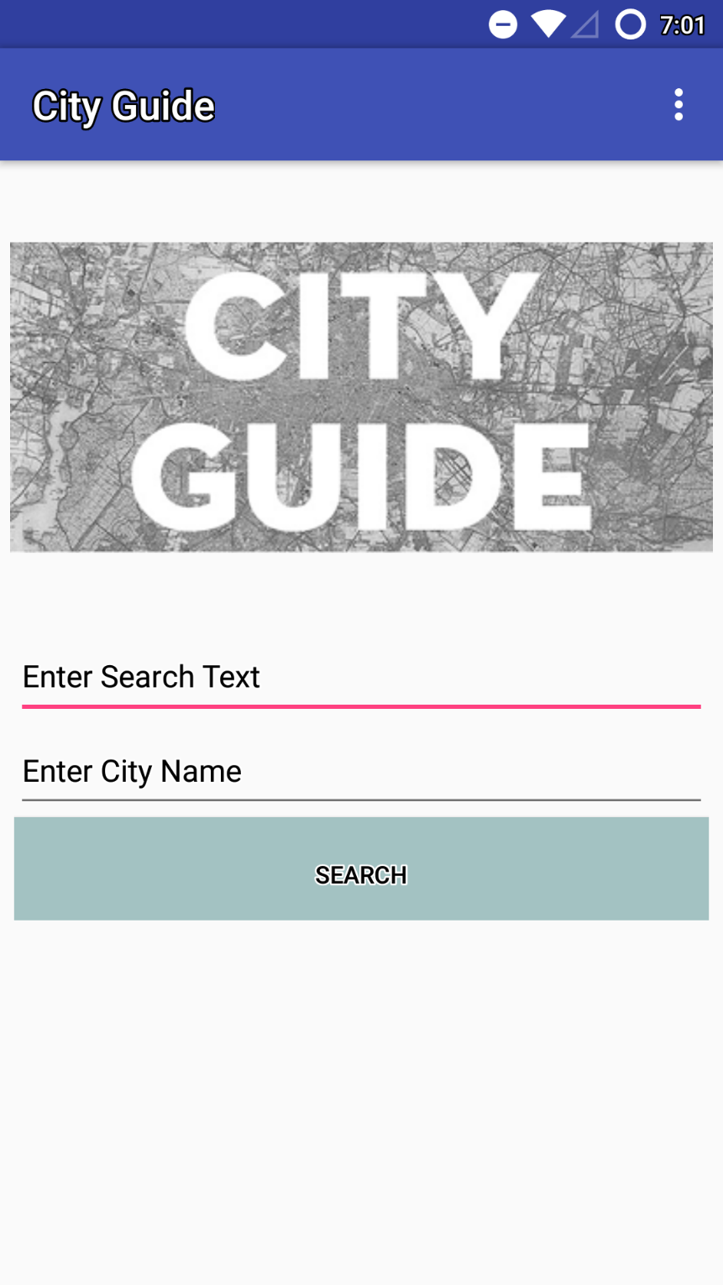

* The user can enter his search attribute and the city he wants to visit, for which results are shown below

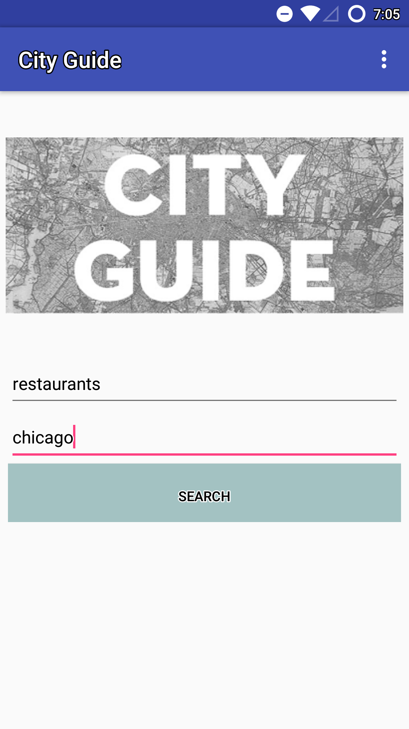

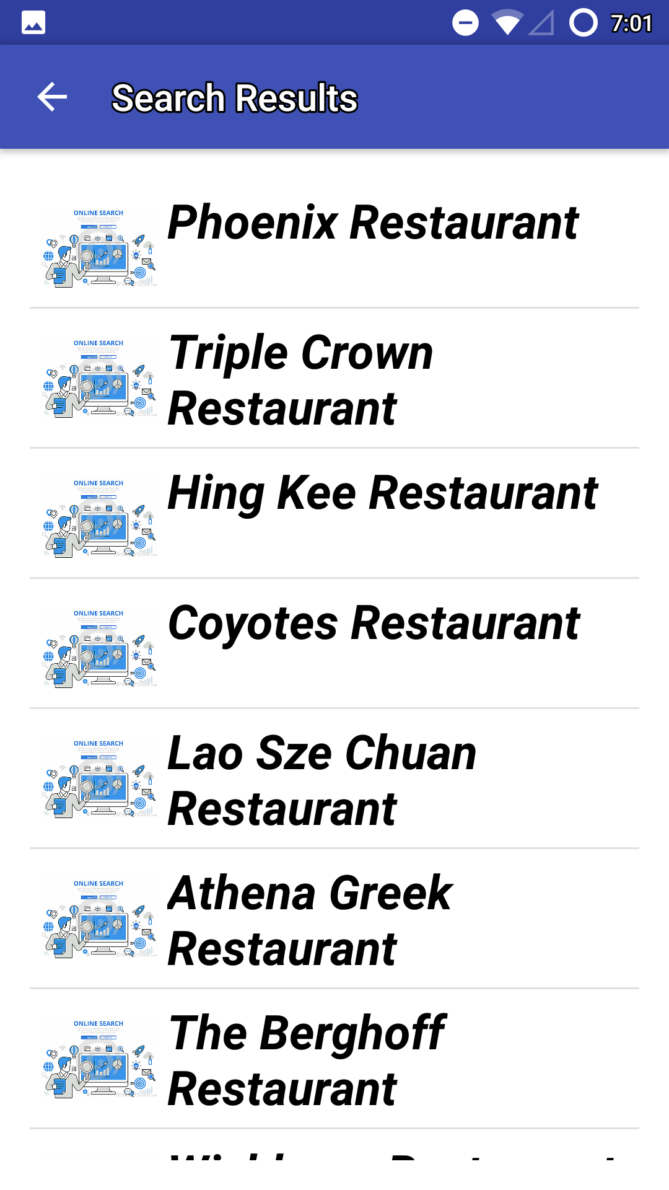

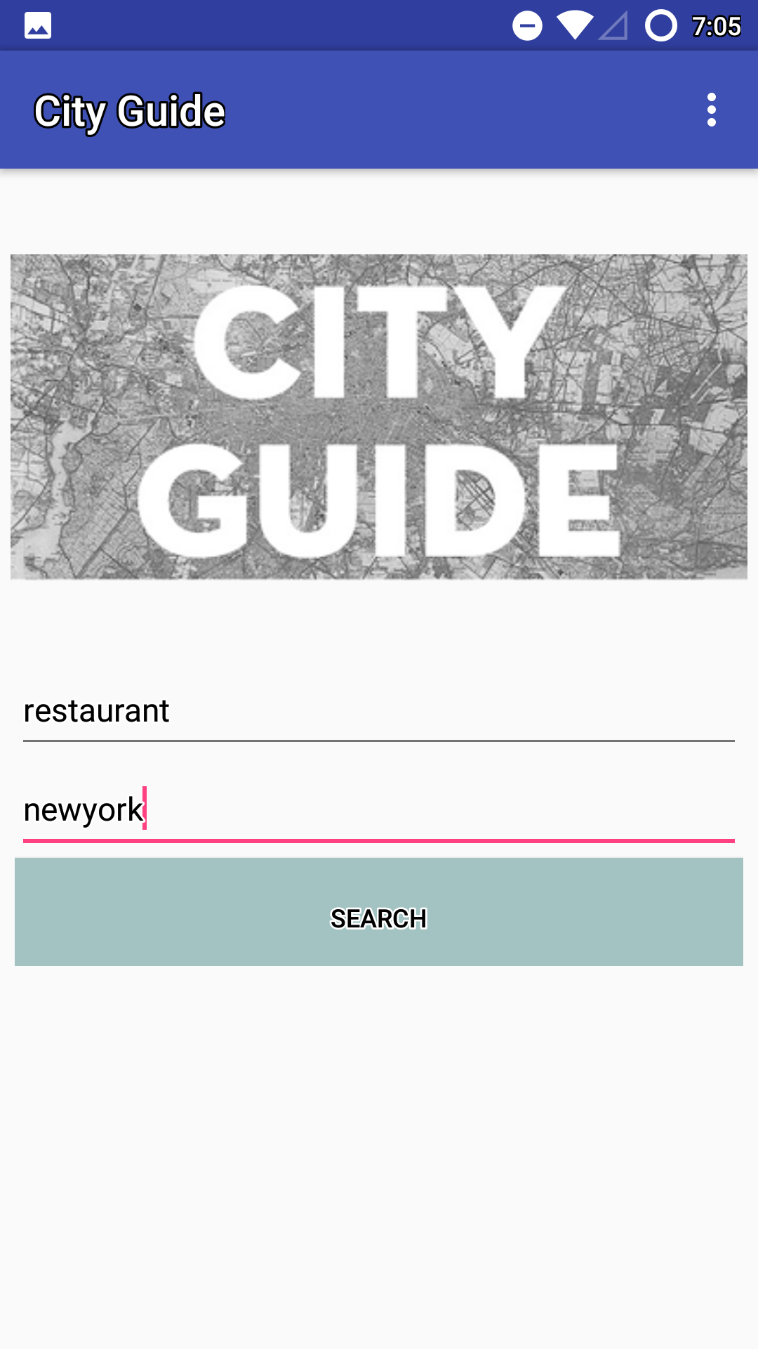

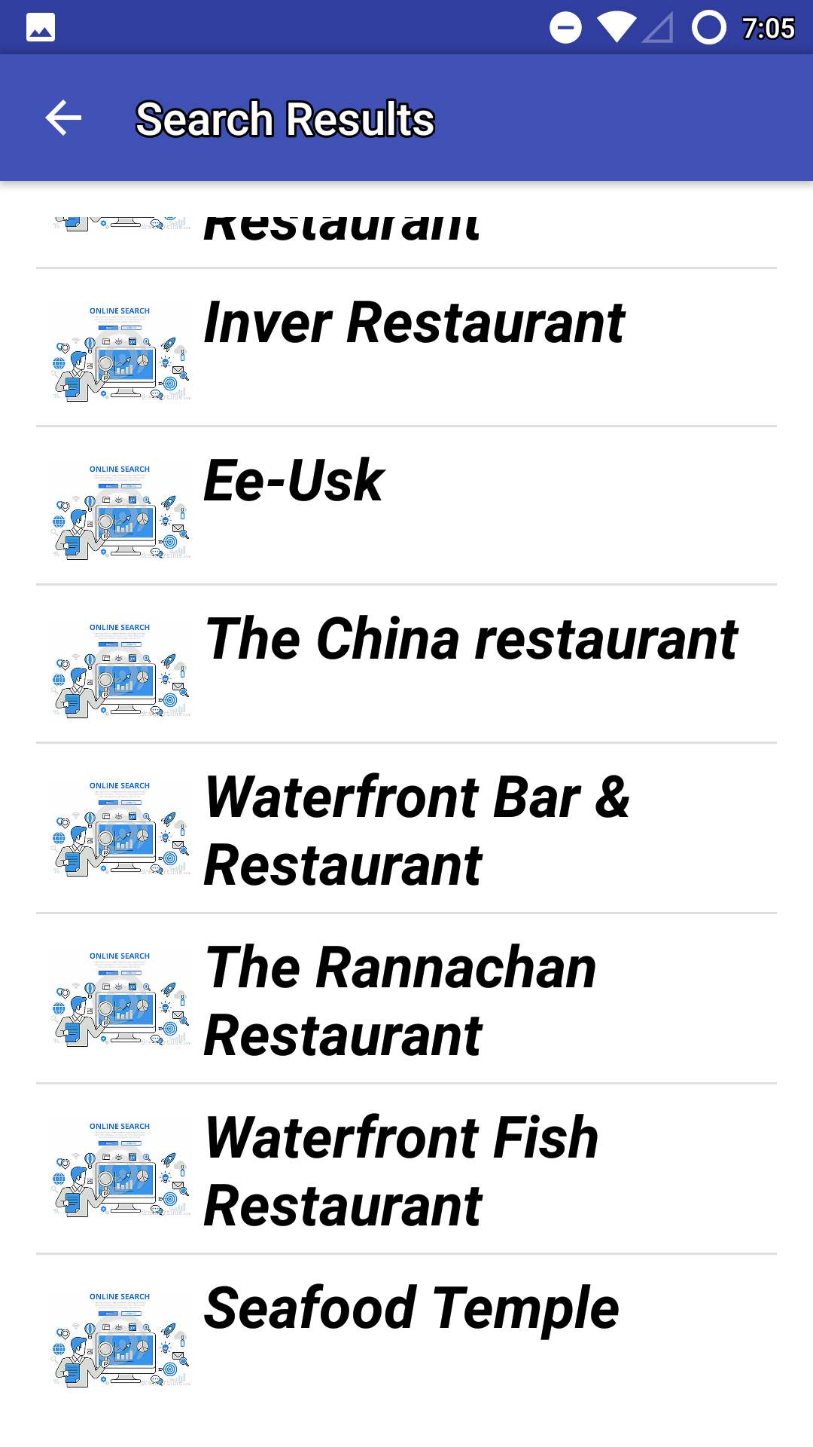

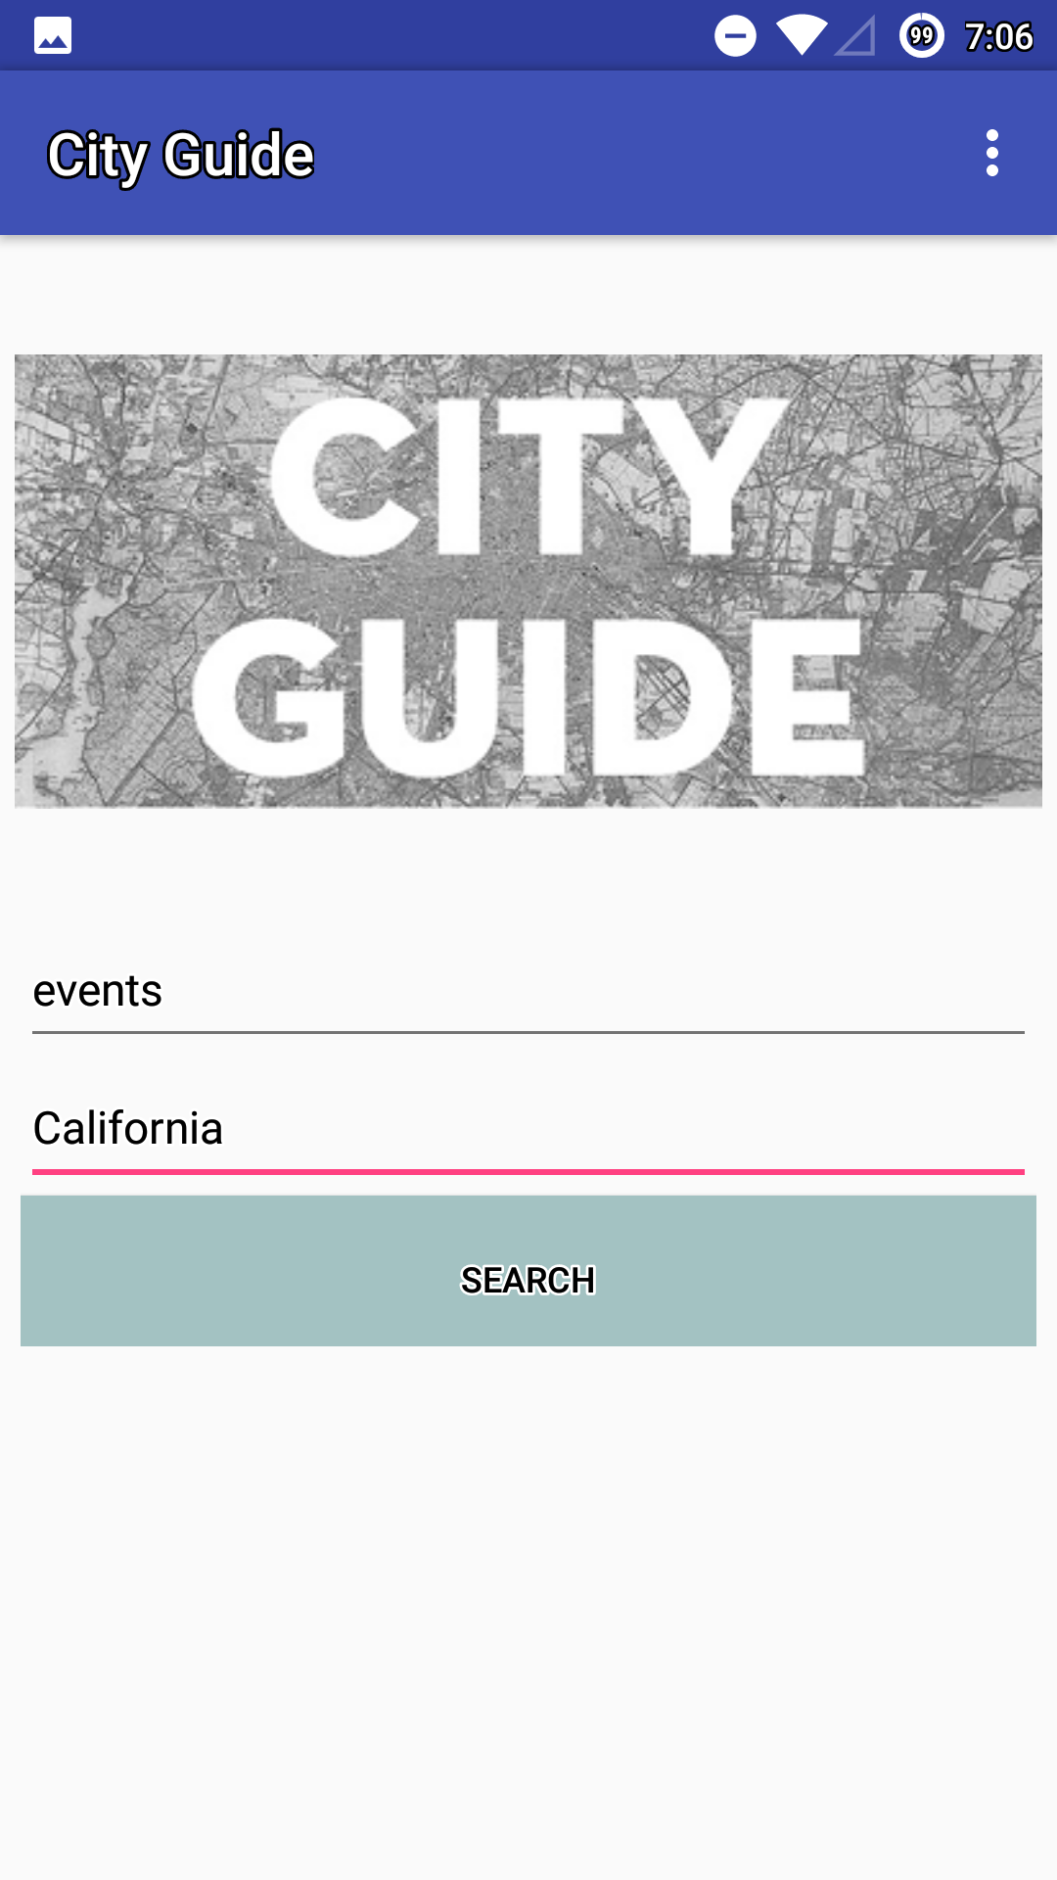

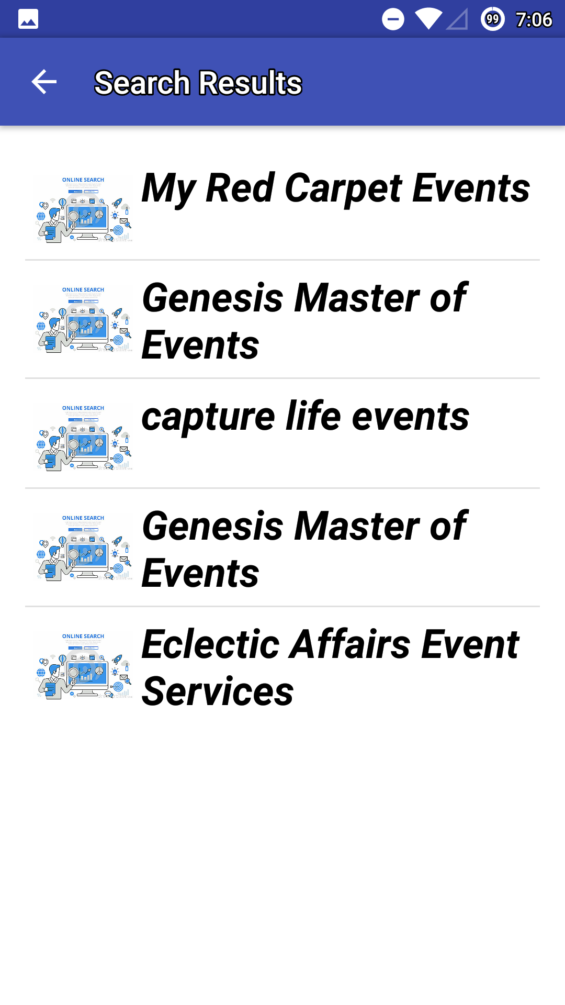

2.14 Storing Data in M-Lab:

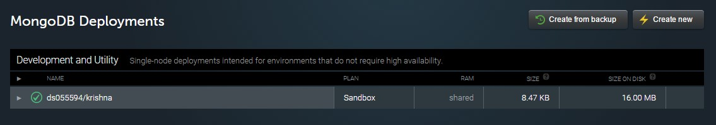

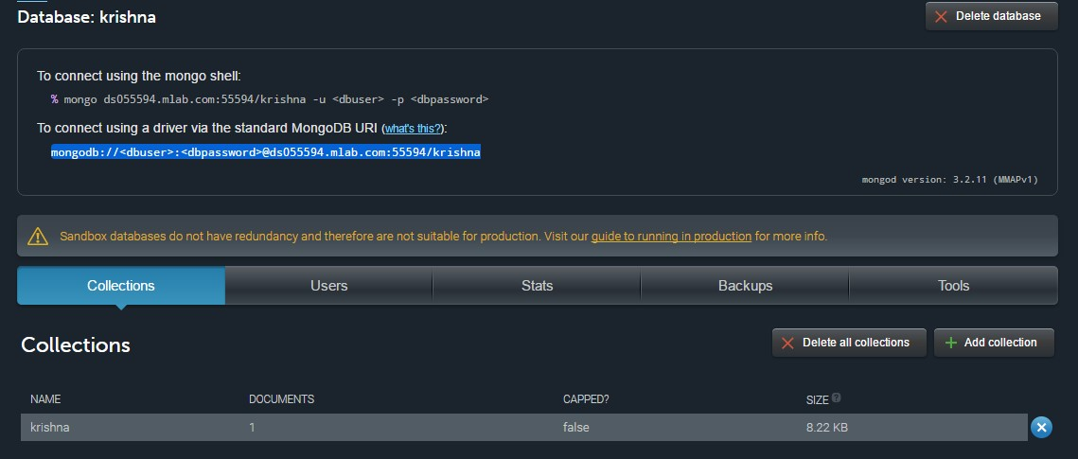

2.15 Project Management:

Burndown Charts:

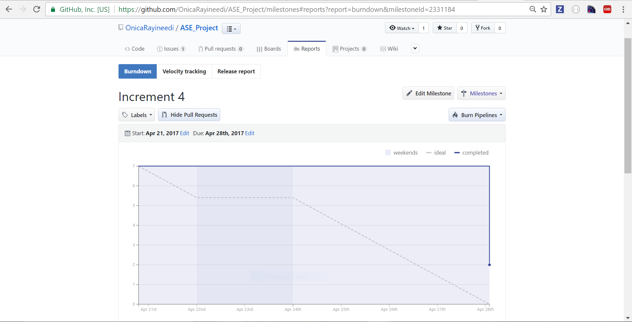

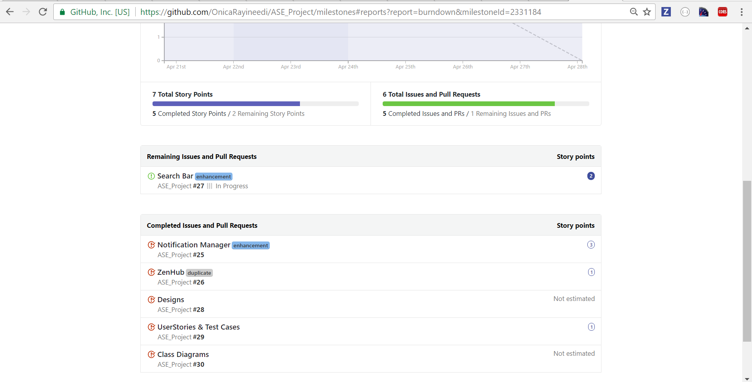

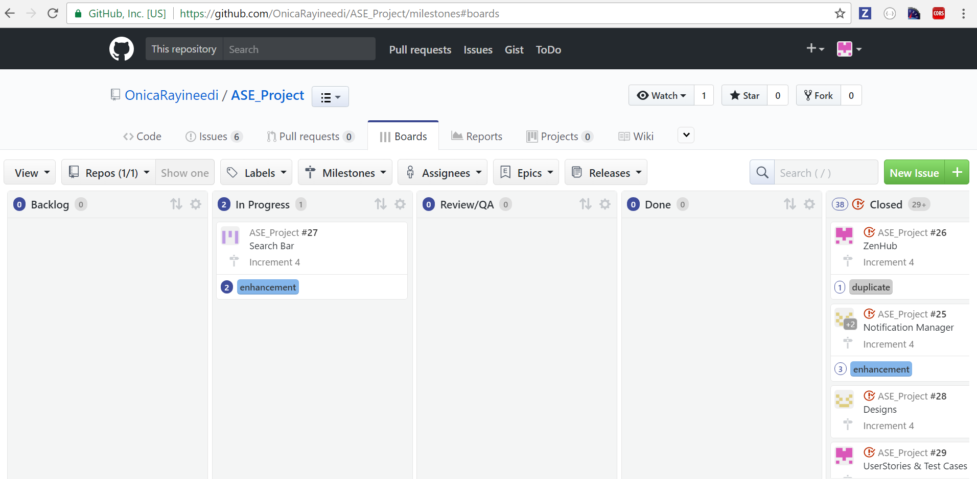

2.16 Final Project Evaluation:

When we proposed this project, our main aim of the project is to develop an android application which allows user to get entire information about the place he or she wants to visit. As, passing through each increment we implemented all major features of the application which we thought about such as getting the tourist places, restaurants, travel & transport, and events of the place the user wants to visit or the place the user is in. Also, thought of implementing Google-360 degrees view of the place the user wants to visit but, google-360-degree view is available only for very few places this restricted us to implement this feature. This Project is implemented using Agile process model which made us to implement and enhance the project at each stage.

**3. Project Proposal**

**Objective:**

It enables people to know about places and areas instantly that they are not familiar with and provide them with the reviews of past and an ability to share their experiences.

**System Features:**

* Depending on the User Location, Tourist Attractions in a place can be displayed
* Entire information such as distance from current location, history, significance, images, and reviews etc. of a place can be viewed
* Associated with various applications which allows to view and book different amenities which are necessary to accomplish the trip
* User can view and record the reviews about the visited place

**Significance or Uniqueness:**

* The information in the application can be shared among tourists instantly and analyzed by the shared ones.
* The main disadvantage of insufficient information of the resources, untapped opportunities for tourism companies and the enhancement of the travel experience is overcome by providing meaningful insight for the trips.
* It provides connectivity to many smart applications for travelers.
* It provides Google’s information and resource source for marketers.
* It aims to resolve the tourism industry’s problem of lacking profitable products and services, which adds value to travelers’ experience during their trip by recognizing their prominent needs and new technological developments that will affect the on-site travel experience.

**4. Project Plan**

**4.1 Class Diagram:**

This diagram depicts the static structure of the Application using Classes and their Attributes.

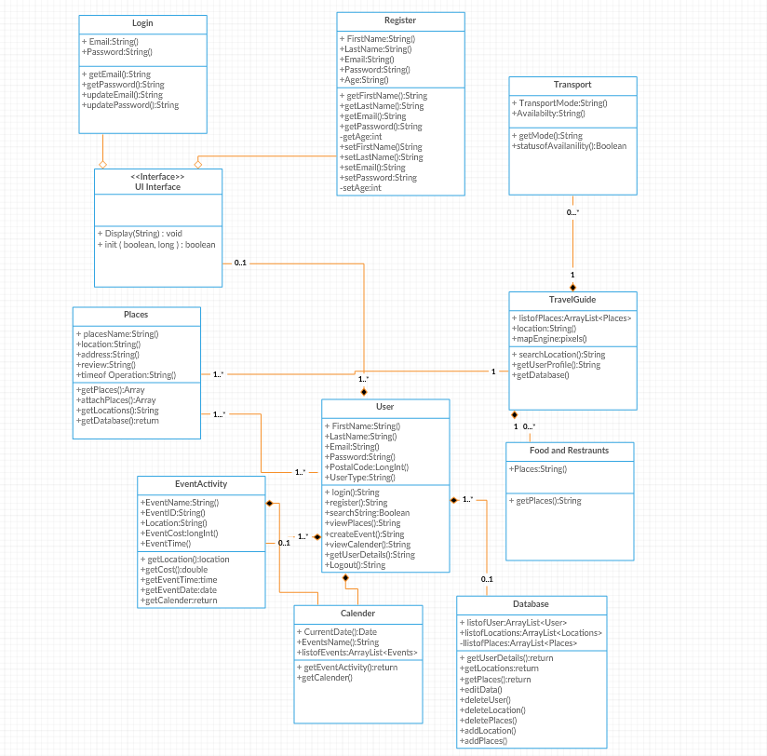

**4.2 Sequence Diagram:**

This Sequence Diagram depicts the interaction mechanism of the objects implemented in the system application.

“Sequence Diagram for Login and registration:”

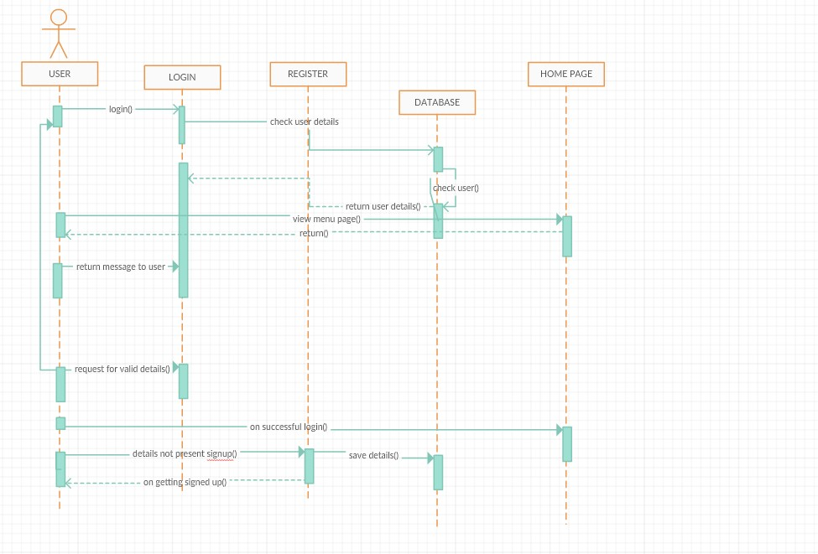

“Sequence Diagram for Home Page:”

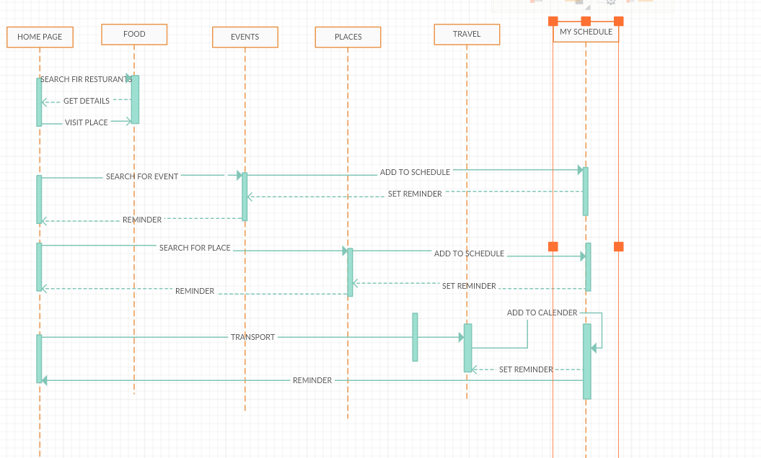

**4.3 Software Architecture:**

Structure and Behavior of the application is described in the system architecture.

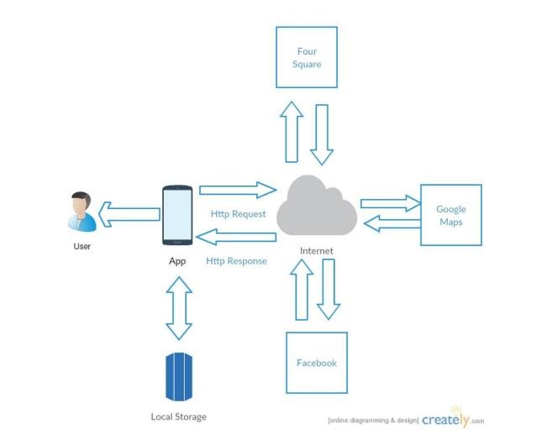

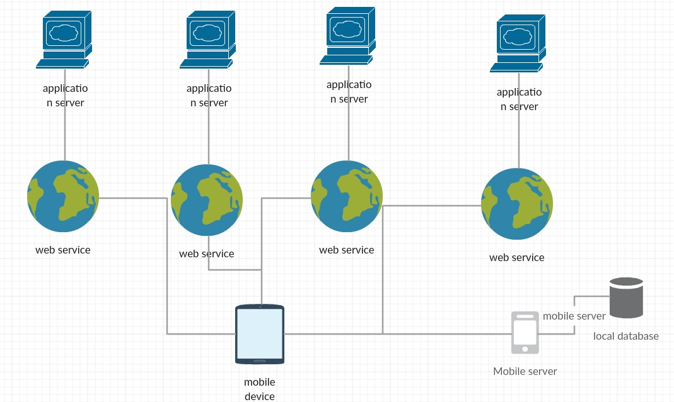

**4.4 Use Case Diagram:**

Use case diagram represents the interaction of user with the application

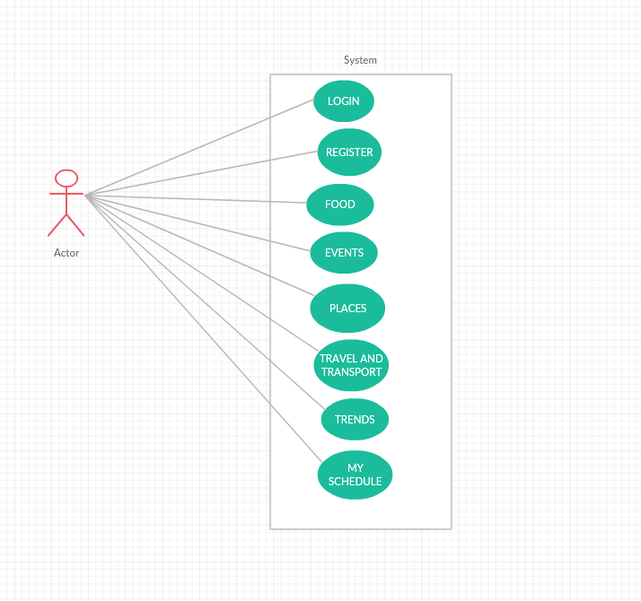

**4.5 User Stories:**

|  |  |  |
| --- | --- | --- |
| As a | I want to | So, that |
| User | Search for the tourist places and events based on my location | I can visit that place as a tourist |
| Get the various Tourist Attractions located in that location | I can visit all the Tourist Attractions located in that place |
| Get Directions and navigation to the Tourist place selected | I do not have any problem in finding the location of the selected place |
| Get all the information such as contact number, Locations, images, video’s (if present) and reviews | I can gain more knowledge about that place |
| Get all the details about different locations based on user choice | I do not face any problem by visiting that place |
| To schedule events and update calendar | I can view the dates and events planned on that days (such as visiting a place) |
| To get the Notifications about scheduled events | I can review the added events |

**4.6 Unit Testing:**

|  |  |  |  |
| --- | --- | --- | --- |
| Case | Test Case Description | Expected Result | Actual Result |
| Events Search | On searching the location | Display the nearby events | PASS |
| Places Search | On searching the Location | Display the nearby visiting spots | PASS |
| Get Directions | On clicking on a location | Display G-Maps linked with the location along with the address and Contact Info | PASS |
| Travel & Transport | On searching the Location | Display places to live and transportation facilities | PASS |
| Food | On searching the Location | Display nearby restaurants | PASS |
| Locations Search | On Entering the Location and attribute user wants to search | Display the search results of the Location entered | PASS |
| Receive Notifications | On Scheduling Events | Receive Notifications on Scheduling Events | PASS |

**5. Project First Increment**

**Implementation:**

**Technologies used:**

Android Studio, M-lab

**Work Completed:**

* Designed Architecture of the application
* Designed Login and registration pages
* Collected related information which will be used for further implementation of the Application

**First Increment Report:**

<https://github.com/OnicaRayineedi/ASE_Project/wiki/Project-Proposal-1>

**6. Project Second Increment**

**Implementation:**

Technologies used: Android Studio, M-lab

Work Completed:

* Designed Architecture of the application
* Designed Login and registration pages
* Collected related information which will be used for further implementation of the Application
* Designing home page
* Database implementations

**Second Increment Report:**

<https://github.com/OnicaRayineedi/ASE_Project/blob/master/Project%20Second%20Increment/Documentation/Project%20Increment%202.pdf>

**7. Project Third Increment**

**Implementation:**

Technologies used: Android Studio, M-lab

Work Completed:

* Designed Architecture of the application
* Designed Login and registration pages
* Collected related information which will be used for further implementation of the Application
* Designing home page
* Database implementations

**Third Increment Report:**

<https://github.com/OnicaRayineedi/ASE_Project/wiki/Project-Third-Increment>

**8. Project Fourth Increment**

**Implementation:**

Technologies and Platforms used:

* HTML 5
* CSS 3
* JavaScript
* MongoDB
* Android Studio

Work Completed:

* Designed Architecture of the application
* Designed Login and registration pages
* Collected related information which will be used for further implementation of the Application
* Designing home page
* Database implementations

**Fourth Project Report:**

<https://github.com/OnicaRayineedi/ASE_Project/blob/master/Project%20Fourth%20Increment/Documentation/Project%20Plan%20and%20Fourth%20Increment.pdf>

**GitHub wiki page URL:**

<https://github.com/OnicaRayineedi/ASE_Project/wiki/Project-Final-Report>

**YouTube URL:**

<https://www.youtube.com/watch?v=SsT5lrH0HMM&feature=youtu.be>

**9. Project Management**

**Implementation:**

Technologies and Platforms used:

* HTML 5
* CSS 3
* JavaScript
* MongoDB
* Android Studio

Work Completed:

* Designed Architecture of the application
* Designed Login and registration pages using MongoDB
* Designing home page
* Implemented on G-Maps API
* Implemented on Four Square API
* Implemented Scheduling Task
* Implemented Notification Task
* Improving the user interface of the Application
* Database implementations

**Responsibility and Tasks Accomplished:**

|  |  |  |  |
| --- | --- | --- | --- |
| Venkata Krishna Podili | Onica Sai Prasanna Lakshmi Rayineedi | Mamatha Yadav Chekuti | Sreelekha Reddy Kommareddy |
| Four Square API to retrieve food and events information | Four Square API to retrieve places and Transport Information | Google Maps API to retrieve the Location Information | Google Maps API to retrieve the Location Information |
| Search Bar Implementation | Scheduling a visit to a Location | Scheduling a visit to a Location | Wireframes Designing |
| UI Implementations | Enabling Notifications | UI Implementations | Enabling Notifications |
| M-Lab Storing | User Stories and Test Cases | Class Diagrams Designing | Facebook Login |

**Contribution:**

* 1. Onica Sai Prasanna Lakshmi, Rayineedi – 25%
  2. Venkata Krishna, Podili– 25%
  3. Mamatha Yadav, Chekuti– 25%
  4. Sreelekha Reddy Kommareddy-25%

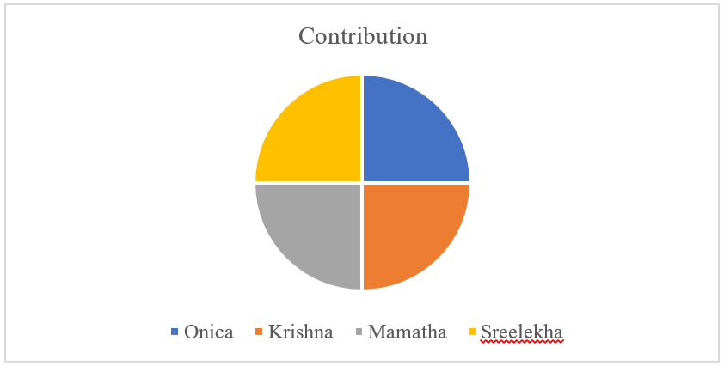

**Future Scope:**

For future implementation for this application would be a feature to write and read the reviews to the restaurants the user planning to visit and to provide any on call service enabling them to clear queries if any.

**Bibliography:**

* <https://creately.com/>
* [https://stackoverflow.com](https://stackoverflow.com/)
* <https://www.raywenderlich.com/109843/common-design-patterns-for-android>